Process to test the functionality:

Once you download the complete source code from the below git repository.

<https://github.com/VasudevaKumar/mantraapp>

In the Zip folder contains both source code and build file.

Build file path : [dist/mantraapp](https://github.com/VasudevaKumar/mantraapp/tree/master/dist/mantraapp)

Please copy the ‘mantraapp’ from the dist folder and move to any Virtual Directory.

Ex: If we are using apache XAMPP , then move the ‘mantraapp’ folder to /xampp/htdocs/

In the browser it should be <http://localhost/mantraapp>

**Functionality of the CRUD application.**

Displaying list of details with pagination.

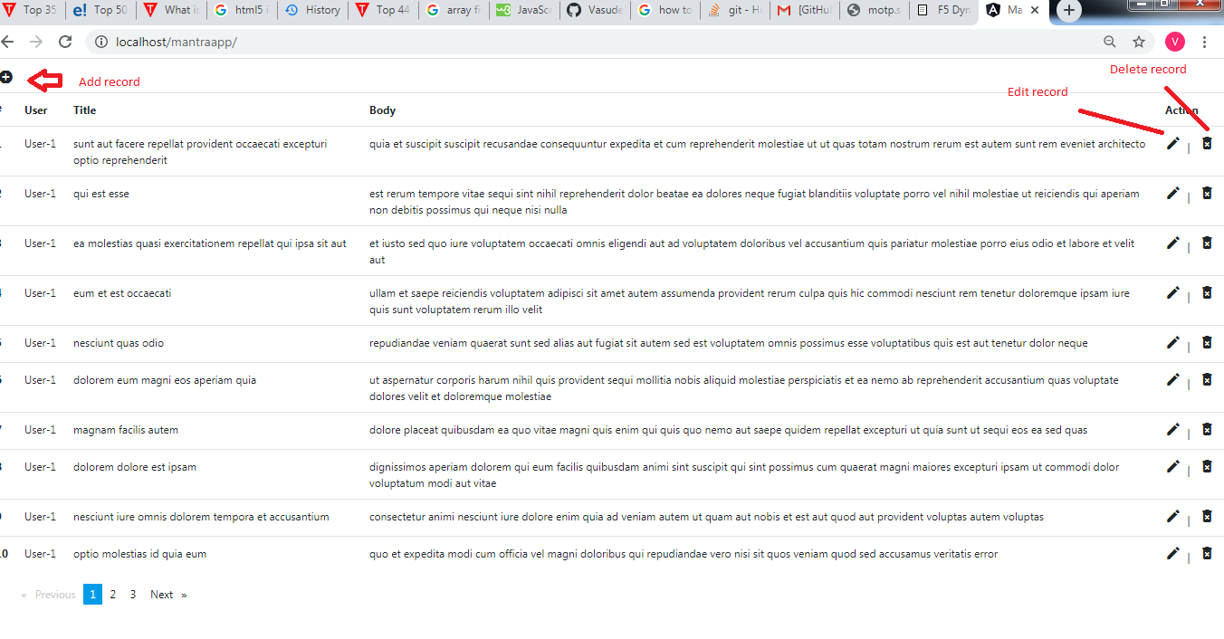

Add record.

